**Range input and text area in HTML**

1. **Range input**

**Attributes**

1. **Input set to range.**
2. **Id should have the same value as a label to link with each other.**
3. **Value attributes set the slider value at starting.**
4. **Step attribute sets steps in which the slider will increase.**
5. **Min and max is to set the range of the slider.**

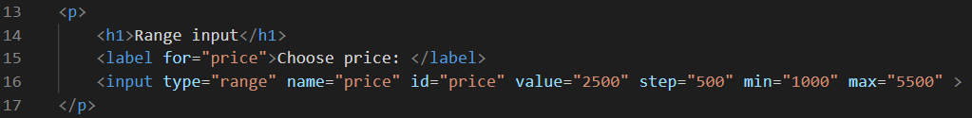

**Output**

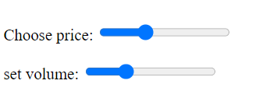

**2. Text area in HTML**

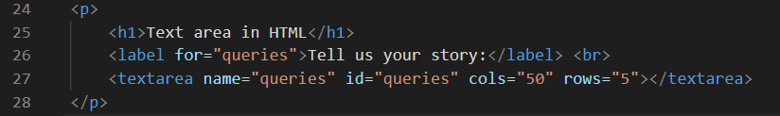

**Output**

